Label the South American Countries | Geography Printouts
Label the countries, oceans, and geographic features of South America on the map below.

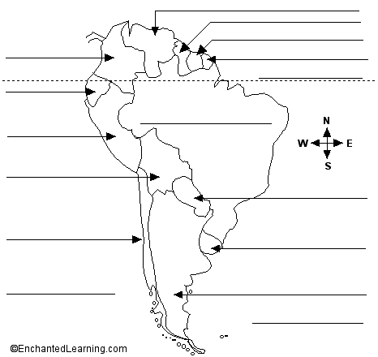

Argentina - A large country in southeastern South America.  Atlantic Ocean - The ocean that borders South America on the east.  Bolivia - The westernmost of the two landlocked (not bordering an ocean) countries in South America.  Brazil - The biggest country in South America. It is the easternmost country in South America.  Chile - A long, thin country in southwestern South America.  Colombia - A country in the far northwest of South America. The equator passes through southern Colombia.  Ecuador - A country in northwestern South America; the equator passes through northern Ecuador. Ecuador borders the Pacific Ocean, is south of Colombia, and north of Peru.  Equator - An imaginary line around the earth, halfway between the North and South Poles. | French Guiana - An overseas department of France that is located in northern South America. It borders the Atlantic Ocean, Brazil, and Suriname.  Guyana - A small country in northern South America. It borders the Atlantic Ocean, Brazil, Venezuela, and Suriname.  Pacific Ocean - The ocean that borders South America on the west.  Paraguay - The easternmost of the two landlocked (not bordering an ocean) countries in South America.  Peru - It borders the Pacific Ocean.  Suriname - A small country in northern South America. It borders the Atlantic Ocean, Brazil, Guyana, and French Guiana.  Uruguay - A small country in southeastern South America that is bordered by Brazil, Argentina and the Atlantic Ocean.  Venezuela - A country in the far north of South America. It borders the Atlantic Ocean, Colombia, Brazil, and Guyana.

